About Me
Please make sure that this stays with me.
You can keep a copy for my file.
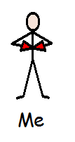

If you wish to you can put a photograph here.

THIS IS ME

My name is:

I like to be called: My Date of Birth: My NHS Number: My Contact Details: My Religion:
This is My Condition
(Brief Description)

I Like:
I Don’t Like:

Behaviours which might challenge (including triggers and how best to support me)

The person I would like you to contact is: The person who knows me best is:
The person with Power of Attorney is:

Tick one of the following
I do not need support with Communication: I do need support with Communication:

Sight- any difficulties or aids

Please do not move things as I may not be able to find them
Hearing- any difficulties or aids

HEALTH

I would like doctors and nurses to know this about me:

I would rate my pain on a scale of 1 to 10 as:

Epilepsy- a description of my seizures
Known Allergies

I have / have not attached a copy of my repeat prescription.

I like to take Medication by: Liquid Tablet Injection

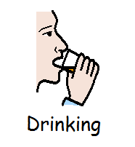
Eating and Drinking
Tell me when and where you have placed my food or drinks.
Likes and Dislikes:
Position; Equipment; Assistance; Consistency/ Cutting Up: Environment, Usual Routine Swallow Risks:

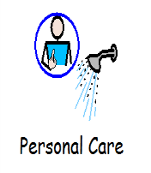
Washing and Dressing
Likes and Dislikes:

Help Needed; Usual Routine:

Hair, Teeth and Toilet
Likes and Dislikes:

Help Needed; Usual Routine:

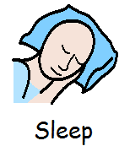
Sleeping
Assistance and Equipment Required; Usual Routine:

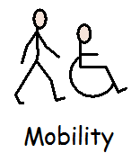
Mobility
Moving Around; Postural Care; Equipment; Falls:

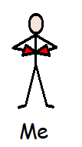
Me
When I am in pain I…

When I am anxious, worried, upset I…

Guidance Notes to Help You Complete About Me

- This About Me document is intended to provide professionals with information about the person with a disability and/or health condition as an individual. This will enhance care and support given while the person is in an unfamiliar environment. It is not a medical document and will require updating as necessary.

This is me: A description of my condition and information about me.

Communication: Words/symbols/photographs/communication aids. Do I use gestures, pointing or other communication indicators? Can I read and write? How do I indicate hunger/thirst? Include anything that may help people identify my needs. How do I express my choices? Speak slowly, clearly, no jargon, use pictures, objects, explain things clearly.

Any History of behaviours which might challenge: Any self harming, physical or verbal aggression, how do you manage these behaviours? How to keep me safe?

Health: Do I need any aids - glasses, hearing aid. How is it best to approach me? Am I hyper or hypo- sensitive? Epilepsy please include a seizure description record.

Medical Interventions: Are there any things that people could do to help support me with having medical interventions for example distraction, safe holding?

Medication: Do I have a usual routine about the way I like my medication, with a particular drink or food, put directly into my hand?

Eating/Drinking: Do you need to ensure I have adjusted my position properly to eat? Do I need assistance to eat or drink? Do I need help to choose food? Can I use cutlery or do I prefer finger foods? Do I need adapted aids such as cutlery or crockery to eat or drink? Does food need to be cut up, mashed, or pureed? Do I have any difficulties swallowing What texture of food is required to help - soft, pureed, vegetarian, religious, cultural needs? Please include any information about my usual appetite.

Personal care: (e.g. washing, hair-care, bathing, brushing teeth, dressing) what are my normal routines? Do I have any preferences? What is the usual level of assistance required?
Do I need reminding to go to the toilet? Do I need to be taken to the toilet? Do I need any assistance to maintain my personal hygiene?

Sleep: Usual sleep patterns and bedtime routines. Do I like a light left on? Do I need help to access the toilet at night? Position in bed, any special mattress, pillow, do I need a regular change of position.

Mobility: Am I fully mobile or do I need help? Is there anything I need to support my posture? Do I need a walking aid? Is my mobility affected by surfaces? Can I use stairs? Can I stand unaided from a sitting position? Do I need a special chair or cushion? Do my feet need raising to make me more comfortable? Am I able to adjust my position in bed/chair?

Footnote:
This document (with minor amendments) has been reproduced with the kind permission of Design and Print Services of The Ipswich Hospital NHS Trust. The Suffolk Disability and Health Action Group would like to thank the Hospital and everyone involved in the development of About Me.

