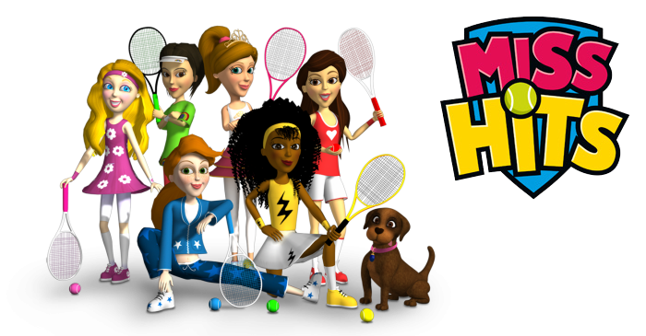

Lil Miss-Hits Training
Application Form

What is Lil Miss-Hits?

A 6 session block designed to introduce girls age 5-8 to starter tennis in a fun environment. Lil Miss-Hits will develop the skills needed to play tennis and a group of friends to play with. It’s a non-technical course so you don’t need to be a qualified coach to deliver it. Each session lasts 45 minutes and is full of simple skill building activities and games. Perfect for teachers, students, mums, sports leaders, community workers and club members. Lil Miss-Hits makes starter tennis delivery simple and fun.

Course details
Date: Monday 15th May 2017

Time: 9.30 – 12.30pm

Venue: Waterlane Leisure Centre, Water Lane, Lowestoft, Suffolk, NR32 2NH

Cost: Free

Training Ambassador: Emily Wharton

Applicant details

Name:

Email:

Phone:

Address:

Tennis Venue or School (if applicable)

Coach Code (if applicable)

T-shirt size

What do you plan to deliver following the training?

Where do you plan to deliver She Rallies activities following the training?

How many girls do you expect to get involved in your sessions following the training?

Please let us know of any other requirements you may have when attending the training course

Please complete the application form in full and return to your Suffolk She Rallies Ambassador Emily Wharton. Address: The Tack Room, Mendlesham Green, Stowmarket, Suffolk, IP14 5RE or Email your application to sherallies.suffolk@gmail.com no later than Monday 8th May. If you have any questions or you would like some ideas in what you could deliver and where on completion of the course, please contact Emily.

