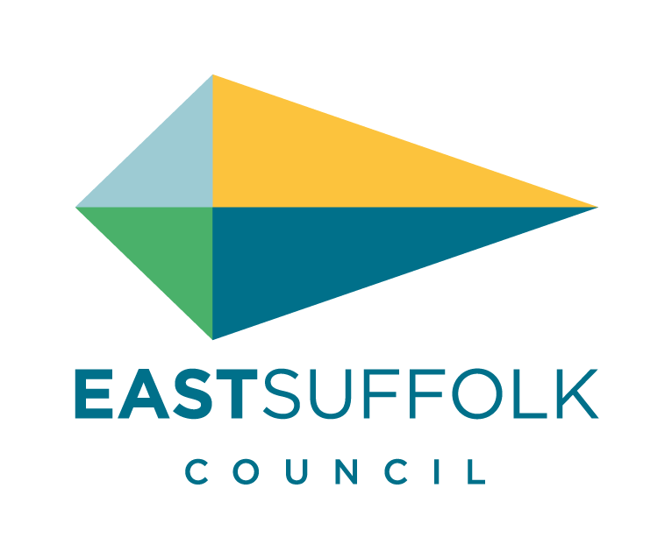
PUBLIC NOTICE

Pavement Licence – New Application

An application has been made for a Pavement Licence under the provisions of Business and Planning Act 2020 as amended by section 229 of and schedule 22 to the Levelling Up and Regeneration Act 2024.

Name of Applicant: Adrian Nunn

Name of Premises: Farmhouse Bakery

Postal Address of Premises: 56 Thoroughfare, Halesworth Suffolk IP19 8AR

Date application was made: 12 June 2025

This application may be viewed on our website - https://www.eastsuffolk.gov.uk/business/licensing/pavement-licences/

Proposed Area:
Size of seating area:
Front of the premises 5.7m X 2.6m

Proposed number of tables and chairs or stall:
4 table, 8 chairs

Proposed days and times:
Monday to Sunday 08:00 to 16:00

Dates between which representations may be made to the Licensing Authority:
Start Date: 13 June 2025
Closing Date: 26 June 2025
Representations must be made in writing to the Licensing Team, East Suffolk Council (as the Licensing Authority) by e-mail to licensing@eastsuffolk.gov.uk

