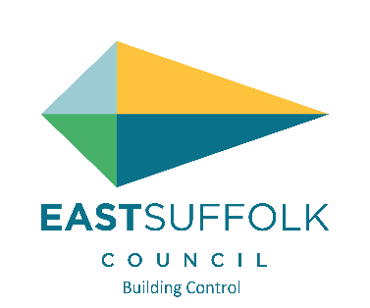

**Commencement statement of work**

**Principle Contractor Details (the lead contractor)**

Name:

Address:

Postcode:       Tel:       Email:

**Reviewing your Notice of Commencement**

When you send us your Notice of Commencement, we will review it to make sure commencement conditions have been met.

If the East Suffolk Building Control are not satisfied the work is to be regarded as commenced they must give the person carrying out the work a notice to that effect (“rejection notice”) within four weeks of the date the notice under paragraph (3C) is given, and the rejection notice must give the reasons for rejection.

Where a notice is given under paragraph (3C) the Building Regulations 2010 (amended) and the period referred to in paragraph (3E) the Building Regulations 2010 (amended) expires without a rejection notice being given, then the work is to be regarded as commenced.

If the person carrying out the work accepts the rejection notice they may not give a further notice under paragraph (3C) the Building Regulations 2010 (amended)unless, having regard to the reasons given by the East Suffolk Building Control, they are satisfied the work is to be regarded as commenced.

A person who gave the notice under paragraph (3C) of the Building Regulations 2010 (amended) may appeal to the First-tier Tribunal against the decision of the relevant authority to reject the notice provided the appeal is made within 21 relevant days beginning with the day after the day on which the relevant authority gives the rejection notice.

If you don’t get any response from East Suffolk Building Control within 4 weeks from the date you sent in your notice, you can consider your work as being commenced.

**Guidance Notes – Understanding when Building Work has reached commencement.**

**Commencement of New Buildings or Extensions which are not a Complex Building**

Work is to be regarded as commenced when the slab is poured.

**Commencement of All Other Building Work (Loft Conversions, Fit Out etc)**

Work is to be regarded as commenced when 15% of the work is completed.

**Commencement of Complex Buildings**

When the foundations supporting the building and the structure of the lowest floor level of that building (but not the other buildings or structures to be supported by those foundations) are completed.

**Definition of Complex Building:**

(a) a building which is to be constructed on the same foundation plinth or podium as any other building or structure;

(b) a building which has more than one storey below ground level;

(c) a building where it is proposed use is primarily as a public building where the public or a section of the public has access to the building (whether or not on payment) provided that the building has a capacity for 100 or more visitors;

**Definition of Public Building:**

(a) a shop or shopping centre;

(b) premises where food or drink are sold for consumption on the premises, including a nightclub, social club or dance hall;

(c) a stadium, theatre, cinema, concert hall;

(d) a sports ground;

(e) an exhibition hall or conference centre;

(f) a hospital or premises for the provision of health care.